Answers

- Human rights Education:is learning about gaining knowledge and understanding of human rights standards, principles, and values, and learning about the systems and mechanisms available to protect human rights.
- Natural right theory states that”Everyone was born with human rights, and therefore, they cannot be lost without one losing oneself”, which means that they came from Nature and God so that none is able to take away.
Example:Right to life,to freedom ,to security and to own property.
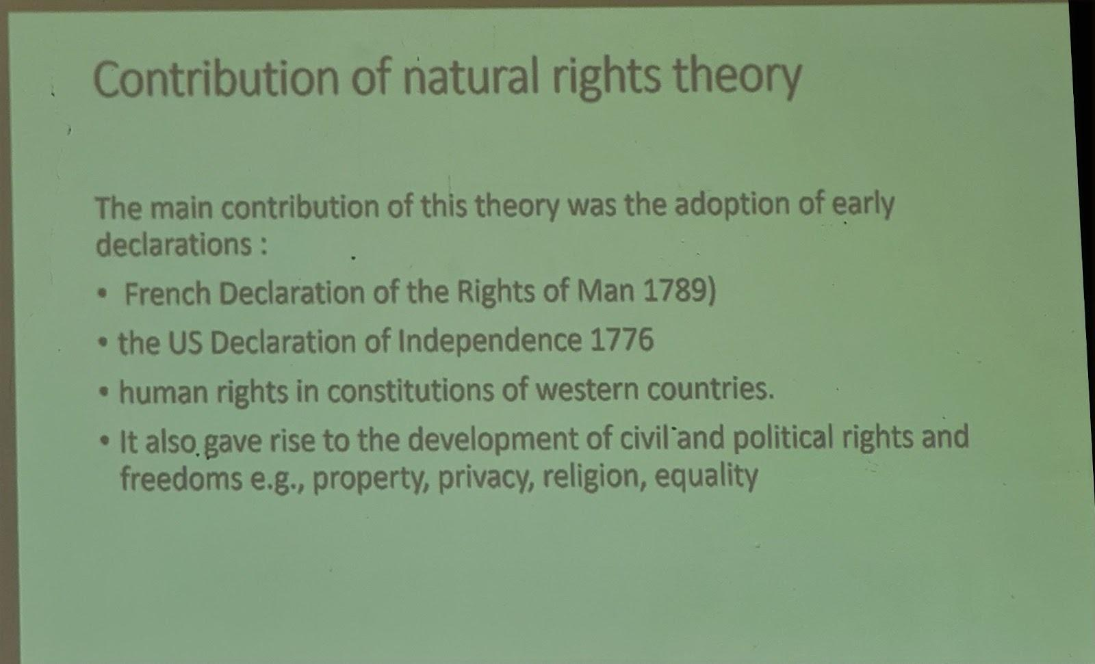

- Positivism in human rights is the idea that human rights comes from laws made by the government,not from nature or morality. Under positivism you've right because the law say so not because you were born with it .
example Right to vote
- Universalism in human rights is the idea that all human beings have the same rights simply because they are human ,no matter their country, religion, culture,gender and race . It is universal because it implies to all people.
example Right to life, right to educate,...
- Relativism in human rights is the idea that human rights depend on culture, society,or laws of a particular county. They are shaped by traditions, customs and social norms
example: education for girls, dress code.
6. Characteristics of Human Rights
- Inherent (or Inalienable): They belong to all human beings by birth and cannot be taken away, surrendered, or transferred.
- Universal: They apply to all people, everywhere, without exception.
- Indivisible: All human rights (civil, political, economic, social, and cultural) are equally important and cannot be separated. The enjoyment of one right often depends on the enjoyment of others.
- Interdependent and Interrelated: The fulfillment of one right often helps advance the fulfillment of others.
- Equal and Non-discriminatory: All individuals are entitled to their rights without discrimination of any kind, such as race, color, sex, language, religion, political or other opinion, national or social origin, property, birth, or other status.
- Guaranteed: They are guaranteed by the rule of law and protected by national and international legal instruments.
- Obligatory: States and other duty-bearers have a legal obligation to respect, protect, and fulfill human rights.
7. Three main categories of human rights
- Civil and Political Rights (First Generation Rights): These rights are primarily about protecting the individual from the state, ensuring fundamental freedoms and participation in government. They are often seen as "freedom from" rights.
Examples: Right to life, freedom of speech, freedom of assembly, right to vote, right to a fair trial.
- Economic, Social, and Cultural Rights (Second Generation Rights): These rights relate to the security and well-being of the individual and include access to essential social and economic goods. They are often seen as "freedom to" or "entitlement" rights, requiring positive action from the state.
Examples: Right to work, right to social security, right to an adequate standard of living, right to education, right to health.
- Solidarity Rights or Collective Rights (Third Generation Rights): These rights are newer and involve the rights of peoples or groups as a whole, often concerning development and the environment.
Examples: Right to development, right to peace, right to a healthy environment.
8. A civil right is a right that ensures equal social opportunities and equal protection under the law. If someone faces discrimination based on their race, age, gender, religion, or other personal characteristics, their civil rights have been violated.
Example: right to life, freedom of expression, freedom of assembly, right to family life and right to movement

9.Political rights are the rights of people to participate in the political life of their communities. Political rights include right to vote, right to run for public office and freedom of assembly and freedom of association.

10.Economic and social rights are human rights that relate to our ability to live in dignity and participate fully in our society. They include rights related to the workplace, social security, and access to housing, food, water, health care and education.

11.Economic rights refer to the human rights that enable us to live in dignity and participate in the society we live in.

12.Social rights are the rights of people to achieve their basic human needs.

13.Cultural rights are the rights of an individual to participate in culture and the right of groups to sustain culture.

14.Collective human rights refer to the rights of particular groups, such as ethnic, religious, or linguistic minorities, to protect and develop their culture, as well as to enjoy their own cultural practices without discrimination or interference.

15.The primary obligation of the State regarding human rights is encapsulated by the Respect, Protect, and Fulfill (RPF) framework.
- Respect (Negative Duty): The State must abstain from violating rights through its own actions (e.g., no torture or arbitrary detention).
- Protect (Preventive Duty): The State must enact laws and mechanisms to prevent third parties (e.g., corporations or individuals) from infringing upon the rights of others.
- Fulfill (Positive Duty): The State must take affirmative actions to provide the necessary conditions and infrastructure for the full realization of rights, especially economic, social, and cultural rights (e.g., establishing education and health services).
Additional critical State duties include ensuring Non-Discrimination, providing Remedies and Accountability for victims, committing to the Progressive Realization of rights utilizing maximum available resources, and guaranteeing Participation and Transparency in governance.
16. The limitations and delogations of human rights.
Limitations (Restrictions) on human rights are:
- Routine and permanent.
- Applied in normal, non-emergency situations.
- Must be prescribed by law (have a legal basis).
- Must be necessary and proportionate to achieve a legitimate aim (e.g., public safety, rights of others).
- They regulate the exercise of the right but do not extinguish it.
- They must be the least restrictive means possible.

- Derogations (Suspensions):
  - Temporary and exceptional suspensions of rights.
  - Occur only when a State officially declares a public emergency threatening the life of the nation (e.g., war or disaster).
  - Must be strictly necessary to meet the emergency.
  - Requires the State to notify relevant international bodies.
  - Non-derogable rights can never be suspended (e.g., the right to life, prohibition of torture, freedom of thought and conscience).
17.Principal Organs and Major Human Rights Bodies in Rwanda
Global/International Bodies (United Nations System)
Principal Organs and Councils
UN General Assembly (GA): Adopts treaties and declarations, such as the Convention on the Rights of Persons with Disabilities and the Declaration on the Rights of Minorities.
UN Security Council: Approves the deployment of peacekeeping operations and can authorize peace enforcement.
Human Rights Council: Oversees Special Rapporteurs and expert mechanisms.
Commission on the Status of Women (CSW): Prepares recommendations and conventions to protect and promote women's rights.
Treaty Monitoring Bodies (Committees) These committees oversee the implementation of specific human rights conventions:
Committee on the Elimination of Discrimination Against Women (CEDAW Committee): Monitors state progress on women's rights and issues general recommendations.
Committee on the Rights of the Child (CRC Committee): Oversees the implementation of the Convention on the Rights of the Child.
Committee on the Rights of Persons with Disabilities (CRPD Committee): Reviews state reports regarding disability rights.
Committee on Economic, Social and Cultural Rights: Issues general comments, such as recognizing indigenous peoples' rights to health.
Political Rights (ICCPR).Human Rights Committee: Interprets the International Covenant on Civil and
Specialized Agencies and Offices
Office of the United Nations High Commissioner for Refugees (UNHCR): Monitors the Refugee Convention, provides protection to refugees, IDPs, and stateless persons.
International Labour Organization (ILO): Active in protecting labor rights, including those of women, children, and indigenous persons.
United Nations Children’s Fund (UNICEF): Advocates for children's rights and provides technical support to governments.
United Nations Educational, Scientific and Cultural Organization (UNESCO): Highlights educational needs and defines gender equality.
World Health Organization (WHO): Focuses on disability prevention and rehabilitation.
Other Mechanisms and Tribunals
International Criminal Court (ICC): Holds individuals criminally responsible for crimes like sexual violence during wartime.
Permanent Forum on Indigenous Issues (PFII): Raises awareness and provides information on indigenous rights.
Special Rapporteurs: Independent experts appointed to report on specific issues, such as the sale of children, trafficking, or human rights and the environment.
II. Regional Human Rights Bodies
African System (African Union)
African Commission on Human and Peoples’ Rights (ACHPR): Monitors the African Charter, establishes working groups, and rules on violations (e.g., SERAC v. Nigeria).
African Court on Human and Peoples’ Rights: Issues binding judgments on human rights violations.
African Peer Review Mechanism (APRM): A voluntary self-monitoring mechanism for good governance.
East African Community (EAC): Works on harmonizing policies regarding gender and community development.
European System
European Court of Human Rights (ECtHR): Protects rights under the European Convention, including environmental rights through the right to private life.
Organization for Security and Cooperation in Europe (OSCE): Active in minority protection, specifically through the High Commissioner on National Minorities.
Inter-American System
Inter-American Commission and Court: Active in protecting the rights of indigenous peoples and refugees.

National Bodies (Specific to Rwanda)
Government Ministries
Ministry of Gender and Family Promotion (MIGEPROF): The lead ministry for child rights and policy coordination.
Ministry of Education (MINEDUC): Responsible for the right to education and the 12-Year Basic Education program.
Ministry of Health (MoH): Manages community health insurance and maternal/child health services.
Ministry of Environment (MoE): Responsible for environmental policy, planning, and monitoring.
Specialized Commissions and Agencies
Gender Monitoring Office (GMO): A constitutionally mandated body that ensures public and private institutions comply with gender equality principles.
National Commission for Children (NCC): Serves as an ombudsman for children, investigating complaints and monitoring rights implementation.
National Child Development Agency (NCDA): The operational arm for child protection and childcare services.
Rwanda Environment Management Authority (REMA): Enforces environmental laws and conducts impact assessments.
Rwanda Green Fund (FONERWA): Finances green projects and climate resilience.
National Women’s Council: Provides a channel for women’s voices from the village to the national level.
Enforcement and Justice Bodies
Rwanda National Police (RNP) - Child and Family Protection Unit: Investigates abuse and exploitation cases.
National Public Prosecution Authority (NPPA): Prosecutes crimes, including specialized handling of gender-based violence.
Rwanda Investigation Bureau (RIB): Works alongside the police in enforcing laws, including environmental protection.
I. Global/International Bodies (UN System)

Principal Organs:
UN General Assembly (GA): Adopts key treaties (e.g., disability, minority rights).
UN Security Council: Approves peacekeeping/peace enforcement.
Human Rights Council: Oversees Special Rapporteurs.
Commission on the Status of Women (CSW): Prepares women's rights recommendations/conventions.
Treaty Monitoring Bodies (Committees): Oversee treaty implementation.
CEDAW Committee: Monitors women's rights progress.
CRC Committee: Oversees Child Rights Convention implementation.
CRPD Committee: Reviews disability rights reports.
Economic, Social and Cultural Rights Committee: Interprets ICCPR; issues general comments (e.g., indigenous health).
Human Rights Committee: Interprets the ICCPR.
Specialized Agencies/Offices:
UNHCR: Monitors Refugee Convention; protects refugees, IDPs, stateless persons.
ILO: Protects labor rights (including women, children, indigenous).
UNICEF: Advocates for children's rights; provides technical support.
UNESCO: Focuses on education and gender equality.
WHO: Focuses on disability prevention/rehabilitation.
Other Mechanisms:
International Criminal Court (ICC): Holds individuals accountable for war crimes (e.g., sexual violence).
Permanent Forum on Indigenous Issues (PFII): Raises awareness on indigenous rights.
Special Rapporteurs: Independent experts reporting on specific issues (e.g., trafficking, environment).
-----II. Regional Human Rights Bodies

African System (African Union):
African Commission on Human and Peoples’ Rights (ACHPR): Monitors African Charter; rules on violations.
African Court on Human and Peoples’ Rights: Issues binding human rights judgments.
African Peer Review Mechanism (APRM): Voluntary good governance self-monitoring.
East African Community (EAC): Harmonizes gender/community development policies.
European System:
European Court of Human Rights (ECtHR): Protects European Convention rights (e.g., environmental rights).
OSCE: Active in minority protection via the High Commissioner on National Minorities.
Inter-American System:
- Inter-American Commission and Court: Protects indigenous peoples' and refugees' rights.
III. National Bodies (Rwanda)

Government Ministries:
- MIGEPROF (Gender and Family Promotion): Leads on child rights/policy.
- MINEDUC (Education): Responsible for the right to education (12-Year Basic Education).
- MoH (Health): Manages community health insurance and maternal/child health.
- MoE (Environment): Responsible for environmental policy/monitoring.
Specialized Commissions/Agencies:
- Gender Monitoring Office (GMO): Ensures compliance with constitutional gender equality.
- National Commission for Children (NCC): Ombudsman for children; investigates complaints.
- National Child Development Agency (NCDA): Manages child protection/care services.
- Rwanda Environment Management Authority (REMA): Enforces environmental laws; conducts impact assessments.
- Rwanda Green Fund (FONERWA): Finances green projects/climate resilience.
- National Women’s Council: Channel for women’s voices from village to national level.
Enforcement and Justice Bodies:
- Rwanda National Police (RNP) - Child and Family Protection Unit: Investigates abuse/exploitation.
- National Public Prosecution Authority (NPPA): Prosecutes crimes, including specialized GBV handling.
- Rwanda Investigation Bureau (RIB): Enforces laws, including environmental protection.
18 . Special Rights referred to as the rights of vulnerable groups, are human rights principles and specific legal protections designed to address the unique vulnerabilities, historical injustices, and specific needs of certain individuals or groups. These rights are necessary to ensure that these groups can enjoy all universal human rights on an equal basis with others.
19. The Rights of Vulnerable Groups
The rights of the vulnerable groups contains the following categorised rights:
- Women's Rights:
  - Freedom from gender-based violence (physical, sexual, psychological).
  - Equal political participation, often supported by temporary special measures (e.g., quotas).
  - Equal economic rights (equal pay, inheritance, access to credit).
  - Maternity protection and reproductive health rights.
  - Non-discrimination in all spheres of life (CEDAW).
- Children's Rights:
  - The right to survival (health, nutrition, adequa]te standard of living).
  - The right to development (education, information, play, culture).
  - The right to protection (from abuse, exploitation, child labor, and harmful practices).
  - The right to participation (having their views heard in matters affecting them) (CRC).
- Rights of Persons with Disabilities (PWDs):
  - The right to accessibility (physical environment, transportation, information, and communication).
  - The right to full inclusion and participation in society.
  - The right to independence and autonomy.
  - The right to non-discrimination and reasonable accommodation (CRPD).
- Minority Rights:
  - The right to practice their own culture, use their own language, and profess and practice their own religion.
  - The right to participate effectively in public life and decisions that affect them.
  - The right to form associations with other members of their group.
- Indigenous Peoples' Rights:
  - The right to self-determination and self-government over internal affairs.
  - The right to their traditional lands, territories, and resources.
  - The right to maintain and protect their traditional knowledge and cultural expressions.
- Refugee and Migrant Rights:
  - The principle of Non-refoulement (protection from being returned to a country where they face serious threats).
  - Access to basic rights like housing, education (especially for children), and work, often subject to host country laws.
  - Protection from discrimination regardless of their legal status.
- Environmental Rights (as collective rights for protection of vulnerable groups):
  - The right to a clean, healthy, and sustainable environment.
  - The right to information, public participation, and access to justice in environmental matters.

20. Why womens deserve “womens rights”.
Women deserve "women's rights" because these rights are basic human rights. They are needed to make life fair and equal for all people.
Here are the main reasons:
- To Fix Old Problems (Systemic Inequality): For a long time in history, women did not have the same chances as men. They couldn't always own land or have the same jobs. Rights like equal pay help to fix these old, unfair rules.
- To Stop Violence: Women face a lot of violence, such as violence at home or sexual attacks. Special laws are needed to protect women, punish the people who hurt them, and make sure they can live safely.
- To Control Their Own Bodies (Reproductive Autonomy): Women must be able to choose when and if they want to have children. This control over their health is very important for their education, work, and future life.
- To Be Part of Decisions (Political Participation): Women are half of the world's people, but they are often not in power (like in government). These rights help women vote and become leaders, so the government makes good decisions for everyone.
- To Be Equal in Money (Economic Equality): Women often earn less money than men for the same job. Rights help them get equal pay, get loans, and share the money and work fairly with men.
- For a Stronger Society (Development): When women are healthy, educated, and earn money, their families and communities become much stronger. Protecting women's rights helps everyone, leading to better education for children and a stronger country.
21.( confusing )
The primary obligation of the State regarding human rights is encapsulated by the Respect, Protect, and Fulfill (RPF) framework. This framework details the three levels of duties a state has towards all human rights, whether they are civil, political, economic, social, or cultural.
The Respect, Protect, and Fulfill (RPF) Framework
- Respect (Negative Duty):
  - What it means: The State must abstain from violating rights through its own actions, policies, or agents. It must not interfere with the enjoyment of rights.
  - Example: The State must not engage in torture, carry out arbitrary arrests, censor the media, or seize private property without due process.
- Protect (Preventive Duty):
  - What it means: The State must enact laws, regulations, and mechanisms to prevent third parties (such as private corporations, non-state actors, or individuals) from infringing upon the rights of others.
  - Example: The State must establish a functional police force and court system, pass laws against gender-based violence, enforce labor laws to prevent exploitation by employers, and regulate pollution by companies to protect the right to health.
- Fulfill (Positive Duty):
  - What it means: The State must take affirmative, proactive measures to establish the necessary conditions and provide the infrastructure for the full realization and enjoyment of rights, especially economic, social, and cultural rights.
  - Example: The State must allocate resources to establish public schools and universities (right to education), build hospitals and fund healthcare systems (right to health), and implement social security programs (right to social security).
Additional Critical State Duties
- Non-Discrimination and Equality: The State has an obligation to ensure that all human rights are enjoyed by all individuals without discrimination of any kind (e.g., race, gender, religion, or disability). Special measures may be required to achieve de facto (actual) equality.
- Remedies and Accountability: The State must provide effective mechanisms for victims of human rights violations to seek justice, redress, and reparations. This includes prosecuting perpetrators.
- Progressive Realization (for ESC Rights): For economic, social, and cultural (ESC) rights, the State is often required to work towards their full achievement utilizing the maximum of its available resources. This means the State cannot retrogress or reduce existing levels of protection without strong justification.
- Participation and Transparency: The State should ensure that individuals and groups can participate meaningfully in the governance and decision-making processes that affect their rights.

